Solve Two-Step Word Problems Using the Four Operations

Lesson 1

On the following pages, students will complete an activity writing story problems, modeling the thinking, and describing the solution process for the problem.

The first four pages give a different expression using each of the four basic arithmetic operations.

The last four pages give the same solution but ask students to write different story problems incorporating each of the four basic arithmetic operations.

|  |  |
| --- | --- |
| 9 + 8  Use the expression above to complete the following tasks.   * In Box A, write a story problem that matches the expression. * In Box B, draw a model or diagram to represent the expression. * In Box C, describe how you would think about and solve the problem you wrote. | |
| Box A | |
| Box B | Box C |
| 14 – 2  Use the expression above to complete the following tasks.   * In Box A, write a story problem that matches the expression. * In Box B, draw a model or diagram to represent the expression. * In Box C, describe how you would think about and solve the problem you wrote. | |
| Box A | |
| Box B | Box C |
| 4 × 12  Use the expression above to complete the following tasks.   * In Box A, write a story problem that matches the expression. * In Box B, draw a model or diagram to represent the expression. * In Box C, describe how you would think about and solve the problem you wrote. | |
| Box A | |
| Box B | Box C |
| 15 ÷ 3  Use the expression above to complete the following tasks.   * In Box A, write a story problem that matches the expression. * In Box B, draw a model or diagram to represent the expression. * In Box C, describe how you would think about and solve the problem you wrote. | |
| Box A | |
| Box B | Box C |
| 3 boxes  Use the expression above to complete the following tasks.   * In Box A, write an **addition** story problem that matches the expression. * In Box B, draw a model or diagram to represent the expression. * In Box C, describe how you would think about and solve the problem you wrote. | |
| Box A | |
| Box B | Box C |
| 3 boxes  Use the expression above to complete the following tasks.   * In Box A, write a **subtraction** story problem that matches the expression. * In Box B, draw a model or diagram to represent the expression. * In Box C, describe how you would think about and solve the problem you wrote. | |
| Box A | |
| Box B | Box C |
| 3 boxes  Use the expression above to complete the following tasks.   * In Box A, write a **multiplication** story problem that matches the expression. * In Box B, draw a model or diagram to represent the expression. * In Box C, describe how you would think about and solve the problem you wrote. | |
| Box A | |
| Box B | Box C |
| 3 boxes  Use the expression above to complete the following tasks.   * In Box A, write a **division** story problem that matches the expression. * In Box B, draw a model or diagram to represent the expression. * In Box C, describe how you would think about and solve the problem you wrote. | |
| Box A | |
| Box B | Box C |

Solve Two-Step Word Problems Using the Four Operations

INSTRUCTIONAL ACTIVITY SUPPLEMENT

Lesson 1

The following page is to be used in a whole-class discussion to introduce the activity students will complete using the Instructional Activity Student Handout.

|  |  |
| --- | --- |
| 17 – 9  Use the expression above to complete the following tasks.   * In Box A, write a story problem that matches the expression. * In Box B, draw a model or diagram to represent the expression. * In Box C, describe how you would think about and solve the problem you wrote. | |
| Box A | |
| Box B | Box C |

Solve Two-Step Word Problems Using the Four Operations

Lesson 2

The following page is an exit ticket. Each student should receive a half page to complete at the end of the lesson.

|  |
| --- |
| Exit Ticket  Guy has a $20 bill. If he buys four baseball card packs that cost $4 each, how much money will Craig have left? |
| Name_____________________________  Exit Ticket  Guy has a $20 bill. If he buys four baseball card packs that cost $4 each, how much money will Craig have left? |

Solve Two-Step Word Problems Using the Four Operations

INSTRUCTIONAL ACTIVITY SUPPLEMENT

Lesson 2

The following six pages give various one-step problem situations. In groups of two or three, students will answer the problem situation and write a follow-up question that relies on the answer from the given problem situation. After writing a follow-up question, student will combine the given problem situation with their follow-up question to create a multi-step problem situation that includes a hidden question.

|  |
| --- |
| Problem Situation #1  Josey is playing a practice math game online. In Round 1, Josey earns 30 stars. In Round 2, Josey earns 20 stars. How many stars has Josey earned so far? |
| Problem Situation #2  Elsa shops for winter clothes. She buys a pair of boots for $35 and socks for $25. How much does Elsa spend on boots and socks? |
| Problem Situation #3  Jaylee started the morning with 12 colored pencils. After lunch, Jaylee found 3 more colored pencils in her classroom. How many colored pencils does Jaylee have now? |
| Problem Situation #4  The apple tree in Johnny’s backyard had 24 apples yesterday morning. During the storm last night, 8 apples fell to the ground. How many apples are in the tree today? |
| Problem Situation #5  Max has $10 in his savings. Max spends $3 on popcorn. How much money does Max have left in his savings? |
| Problem Situation #6  A squirrel gathered and buried 40 acorns. Then a chipmunk took 15 acorns. How many acorns does the squirrel have left? |
| Problem Situation #7  A party-size pizza serves 5 people. How many people can be served with 7 pizzas? |
| Problem Situation #8  Reusable water bottles are on sale for $7 each. How much money will 6 water bottles cost? |
| Problem Situation #9  Tory bakes cookies for a party. She thinks each person will eat 5 cookies. How many cookies does Tory need to bake for 8 people? |
| Problem Situation #10  A jumbo-size package of beads contains 88 beads. One package of beads makes 4 bracelets. How many beads make up each bracelet? |
| Problem Situation #11  Mrs. Jameson’s class brought paper bags to class for a project. Each of the 18 students brought the same amount of bags to class. The class has a total of 54 bags. How many bags did each student bring to class? |
| Problem Situation #12  Chloe spends $21 on 7 polished rocks. How much money does each polished rock cost? |

Solve Two-Step Word Problems Using the Four Operations

Lesson 3

|  |  |
| --- | --- |
| **Understand the Problem** | **Make a Plan** |
| **Carry Out the Plan** | **Look Back** |

1. 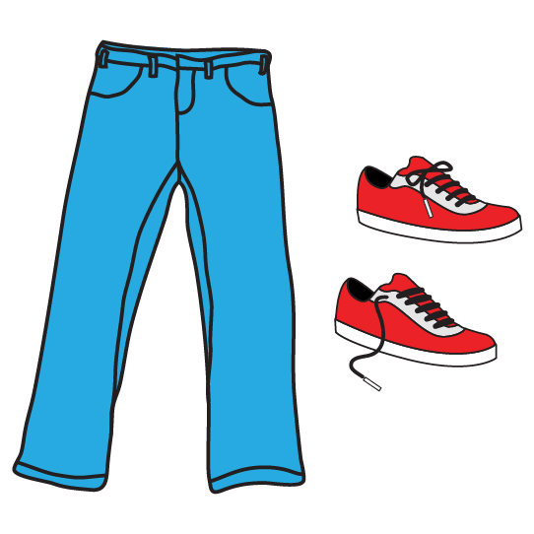Lizzie has $100 to shop for new clothes. She buys 1 pair of shoes and 1 pair of jeans. The shoes cost $30, and the jeans cost $24. How much change will Lizzie get back?
2. Sam is helping at his little sister’s birthday party. Sam has 40 balloons and 12 spoons to use in a party game. Each of the 12 guests needs 3 balloons for the game. How many extra balloons does Sam have?
3. Aidan is cleaning his garage. He plans to put all the sports balls into a plastic tub. Aidan finds 4 soccer balls. He finds 2 more footballs than soccer balls. He sees 2 baseball bats hanging on the wall. How many sports balls will Aidan put into his plastic tub?



1. Kenzie needs 28 hangers for her clothes. She finds 2 packages of 10 hangers. How many more hangers should Kenzie look for?
2. 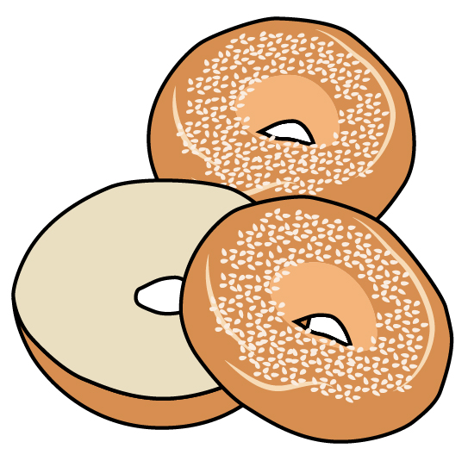Tomas is at the grocery store. He buys 2 blueberry bagels, 4 wheat bagels, and some 2-packs of onion bagels. How many bagels does Tomas buy?
3. Trina is collecting leaves for a science project. On Saturday, she collects 13 oak leaves, 5 elm leaves, and 4 maple leaves. On Sunday, Trina collects twice as many leaves. How many total leaves did Trina collect on Sunday?
4. Dailon collects comic books. He has 30 total comic books. Half of the comic books are about superheroes. Dailon also has comic books about aliens or monsters. Dailon has 2 fewer comic books about aliens than superheroes. How many alien comic books does Dailon have?

Solve Two-Step Word Problems Using the Four Operations

INSTRUCTIONAL ACTIVITY SUPPLEMENT

Lesson 3

**Polya’s Four-Step Problem-Solving Process**

|  |  |
| --- | --- |
| Step 1: Understand the problem   * Begin by reading the problem. Then re-read the problem. * Do you understand all of the vocabulary in the problem? * What are you being asked to do? * Is there enough information to solve the problem? * Is there extra information you don’t need? | Step 2: Make a plan   * How might you solve this problem? * Would a model, diagram, or picture help? * Is there a simpler problem you could solve? * Do you see a pattern? |
| Step 3: Carry out the plan   * Now that you have a plan, take the steps needed to follow your plan. | Step 4: Look back   * Re-read the problem again. * Does your answer make sense? * Double-check your calculations. * Did you answer the question asked? Did you answer all questions asked? |

Solve Two-Step Word Problems Using the Four Operations

Lesson 4

What do you call two dinosaurs that get into an accident?

|  |  |  |  |  |  |  |  |  |  |  |  |  |  |  |  |  |  |  |  |
| --- | --- | --- | --- | --- | --- | --- | --- | --- | --- | --- | --- | --- | --- | --- | --- | --- | --- | --- | --- |
|  |  |  |  |  |  |  |  |  |  |  |  |  |  |  |  |  |  |  |  |
| **5** | **12** | **6** | **1** | **4** | **4** | **11** | **2** | **1** | **10** | **6** | **10** | **2** |  | **3** | **6** | **7** | **8** | **9** | **2** |

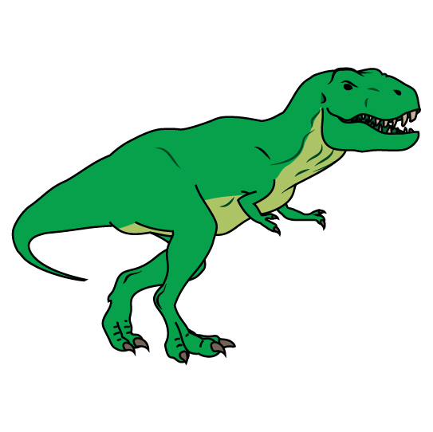

|  |  |
| --- | --- |
| **Problem #1** | |
| Define a variable for the unknown information. | Write an equation using the variable. |
| Solve your equation. |  |

|  |  |
| --- | --- |
| **Problem #2** | |
| Define a variable for the unknown information. | Write an equation using the variable. |
| Solve your equation. |  |

|  |  |
| --- | --- |
| **Problem #3** | |
| Define a variable for the unknown information. | Write an equation using the variable. |
| Solve your equation. |  |
| **Problem #4** | |
| Define a variable for the unknown information. | Write an equation using the variable. |
| Solve your equation. |  |

|  |  |
| --- | --- |
| **Problem #5** | |
| Define a variable for the unknown information. | Write an equation using the variable. |
| Solve your equation. |  |
| **Problem #6** | |
| Define a variable for the unknown information. | Write an equation using the variable. |
| Solve your equation. |  |

|  |  |
| --- | --- |
| **Problem #7** | |
| Define a variable for the unknown information. | Write an equation using the variable. |
| Solve your equation. |  |
| **Problem #8** | |
| Define a variable for the unknown information. | Write an equation using the variable. |
| Solve your equation. |  |

|  |  |
| --- | --- |
| **Problem #9** | |
| Define a variable for the unknown information. | Write an equation using the variable. |
| Solve your equation. |  |
| **Problem #10** | |
| Define a variable for the unknown information. | Write an equation using the variable. |
| Solve your equation. |  |

|  |  |
| --- | --- |
| **Problem #11** | |
| Define a variable for the unknown information. | Write an equation using the variable. |
| Solve your equation. |  |
| **Problem #12** | |
| Define a variable for the unknown information. | Write an equation using the variable. |
| Solve your equation. |  |

Solve Two-Step Word Problems Using the Four Operations

INSTRUCTIONAL ACTIVITY SUPPLEMENT

Lesson 4

The following 12 pages are to be posted throughout the room for students.

The student work page is provided in the Instructional Activity Student Handout.

**Read the problem below.**

1. **Using your work page, identify the unknown quantity you are asked to find. Then define a variable to represent the unknown quantity.**
2. **Write an equation using the given information and the variable defined.**
3. **Solve the equation.**
4. **Find your answer at the bottom of this page. Write the letter of the answer in the box corresponding to the problem number on your work page to decode the riddle.**

|  |  |  |
| --- | --- | --- |
| Your class is celebrating Pi Day! For a special lunch, your teacher is buying pizza. Your class needs 5 pizzas for everyone to have lunch. Pizzas cost $13 each. How much change will your teacher get back if he pays with $80? | | |
| A: $15 in change | N: $65 in change | F: $25 |

**Read the problem below.**

1. **Using your work page, identify the unknown quantity you are asked to find. Then define a variable to represent the unknown quantity.**
2. **Write an equation using the given information and the variable defined.**
3. **Solve the equation.**
4. **Find your answer at the bottom of this page. Write the letter of the answer in the box corresponding to the problem number on your work page to decode the riddle.**

|  |  |  |
| --- | --- | --- |
| After pizza, the class will have pie for dessert. Several students volunteered to bring pie. Sally is bringing 2 pies. Joey and Fryna are each bringing 1 pie. If each pie is cut into 8 pieces, how many pieces of pie will there be? | | |
| E: 8 pieces | I: 24 pieces | S: 32 pieces |

**Read the problem below.**

1. **Using your work page, identify the unknown quantity you are asked to find. Then define a variable to represent the unknown quantity.**
2. **Write an equation using the given information and the variable defined.**
3. **Solve the equation.**
4. **Find your answer at the bottom of this page. Write the letter of the answer in the box corresponding to the problem number on your work page to decode the riddle.**

|  |  |  |
| --- | --- | --- |
| To eat the pizza and pie, everyone needs a plate. Your class has 5 tables with 4 students each. A package of plates contains 16 plates. How many more plates will be needed for the class? | | |
| T: 16 more plates | W: 4 more plates | H: 5 more plates |

**Read the problem below.**

1. **Using your work page, identify the unknown quantity you are asked to find. Then define a variable to represent the unknown quantity.**
2. **Write an equation using the given information and the variable defined.**
3. **Solve the equation.**
4. **Find your answer at the bottom of this page. Write the letter of the answer in the box corresponding to the problem number on your work page to decode the riddle.**

|  |  |  |
| --- | --- | --- |
| Everyone will get a cup of juice. The class needs 21 cups. Johanna brought 10 red cups, and Tyler brought 7 black cups, how many more cups are needed? | | |
| N: 4 more cups | M: 7 more cups | D: 18 more cups |

**Read the problem below.**

1. **Using your work page, identify the unknown quantity you are asked to find. Then define a variable to represent the unknown quantity.**
2. **Write an equation using the given information and the variable defined.**
3. **Solve the equation.**
4. **Find your answer at the bottom of this page. Write the letter of the answer in the box corresponding to the problem number on your work page to decode the riddle.**

|  |  |  |
| --- | --- | --- |
| Suzie has a 64-ounce juice bottle to pour evenly into 6 cups. When pouring the first cup, Suzie spills 4 ounces. If she doesn’t spill anymore, how much juice can go evenly into each remaining cup? | | |
| D: 6 ounces | I: 9 ounces | T: 10 ounces |

**Read the problem below.**

1. **Using your work page, identify the unknown quantity you are asked to find. Then define a variable to represent the unknown quantity.**
2. **Write an equation using the given information and the variable defined.**
3. **Solve the equation.**
4. **Find your answer at the bottom of this page. Write the letter of the answer in the box corresponding to the problem number on your work page to decode the riddle.**

|  |  |  |
| --- | --- | --- |
| To celebrate on Pi Day, your class plays basketball. During his game, Jaymes makes 6 two-point shots and 3 three-point shots. How many points does Jaymes score in total? | | |
| W: 24 points | R: 21 points | K: 9 points |

**Read the problem below.**

1. **Using your work page, identify the unknown quantity you are asked to find. Then define a variable to represent the unknown quantity.**
2. **Write an equation using the given information and the variable defined.**
3. **Solve the equation.**
4. **Find your answer at the bottom of this page. Write the letter of the answer in the box corresponding to the problem number on your work page to decode the riddle.**

|  |  |  |
| --- | --- | --- |
| Brynn has 2 packs of gumballs to share with her table. Each pack has 10 gumballs. If 4 people share the gumballs evenly, how many gumballs does each person get? | | |
| A: 20 gumballs | E: 5 gumballs | O: 2 gumballs |

**Read the problem below.**

1. **Using your work page, identify the unknown quantity you are asked to find. Then define a variable to represent the unknown quantity.**
2. **Write an equation using the given information and the variable defined.**
3. **Solve the equation.**
4. **Find your answer at the bottom of this page. Write the letter of the answer in the box corresponding to the problem number on your work page to decode the riddle.**

|  |  |  |
| --- | --- | --- |
| Because Pi Day is also Albert Einstein’s birthday, each student has an Einstein coloring page. On the counter is a tub of colored pencils. The tub filled with 9 boxes of 12 colored pencils, but 3 colored pencils have been lost. How many colored pencils are in the tub now? | | |
| A: 111 colored pencils | E: 87 colored pencils | C: 105 colored pencils |

**Read the problem below.**

1. **Using your work page, identify the unknown quantity you are asked to find. Then define a variable to represent the unknown quantity.**
2. **Write an equation using the given information and the variable defined.**
3. **Solve the equation.**
4. **Find your answer at the bottom of this page. Write the letter of the answer in the box corresponding to the problem number on your work page to decode the riddle.**

|  |  |  |
| --- | --- | --- |
| During art class, you work on some string art. The circle outline needs 72 holes. First you punch 20 holes. Then you punch 18 more holes. How many holes do you have left to punch? | | |
| K: 34 more holes | L: 32 more holes | M: 36 more holes |

**Read the problem below.**

1. **Using your work page, identify the unknown quantity you are asked to find. Then define a variable to represent the unknown quantity.**
2. **Write an equation using the given information and the variable defined.**
3. **Solve the equation.**
4. **Find your answer at the bottom of this page. Write the letter of the answer in the box corresponding to the problem number on your work page to decode the riddle.**

|  |  |  |
| --- | --- | --- |
| Your teacher bought special pencils with the digits of pi on them. He has 3 packs of 15 pencils. He gives each of the 20 students 2 pencils. How many pencils does your teacher have left over? | | |
| A: 0 pencils  left over | U: 5 pencils  left over | Y: 20 pencils  left over |

**Read the problem below.**

1. **Using your work page, identify the unknown quantity you are asked to find. Then define a variable to represent the unknown quantity.**
2. **Write an equation using the given information and the variable defined.**
3. **Solve the equation.**
4. **Find your answer at the bottom of this page. Write the letter of the answer in the box corresponding to the problem number on your work page to decode the riddle.**

|  |  |  |
| --- | --- | --- |
| The principal provided circular erasers for everyone. She gave your class a bag of 12 erasers, a pack of 24, and 4 loose erasers. How many erasers will each of the 20 students in your class get? | | |
| T: 3 erasers | P: 1 eraser | O: 2 erasers |

**Read the problem below.**

1. **Using your work page, identify the unknown quantity you are asked to find. Then define a variable to represent the unknown quantity.**
2. **Write an equation using the given information and the variable defined.**
3. **Solve the equation.**
4. **Find your answer at the bottom of this page. Write the letter of the answer in the box corresponding to the problem number on your work page to decode the riddle.**

|  |  |  |
| --- | --- | --- |
| To decorate, your class writes the digits of pi on a paper chain and hangs it around the room. The ceiling is 120 inches high. How many 3-inch rings will it take to reach from the floor to the ceiling 5 times? | | |
| Y: 200 rings | S: 72 rings | G: 1800 rings |

Solve Two-Step Word Problems Using the Four Operations

Lessons 1 – 4

1. 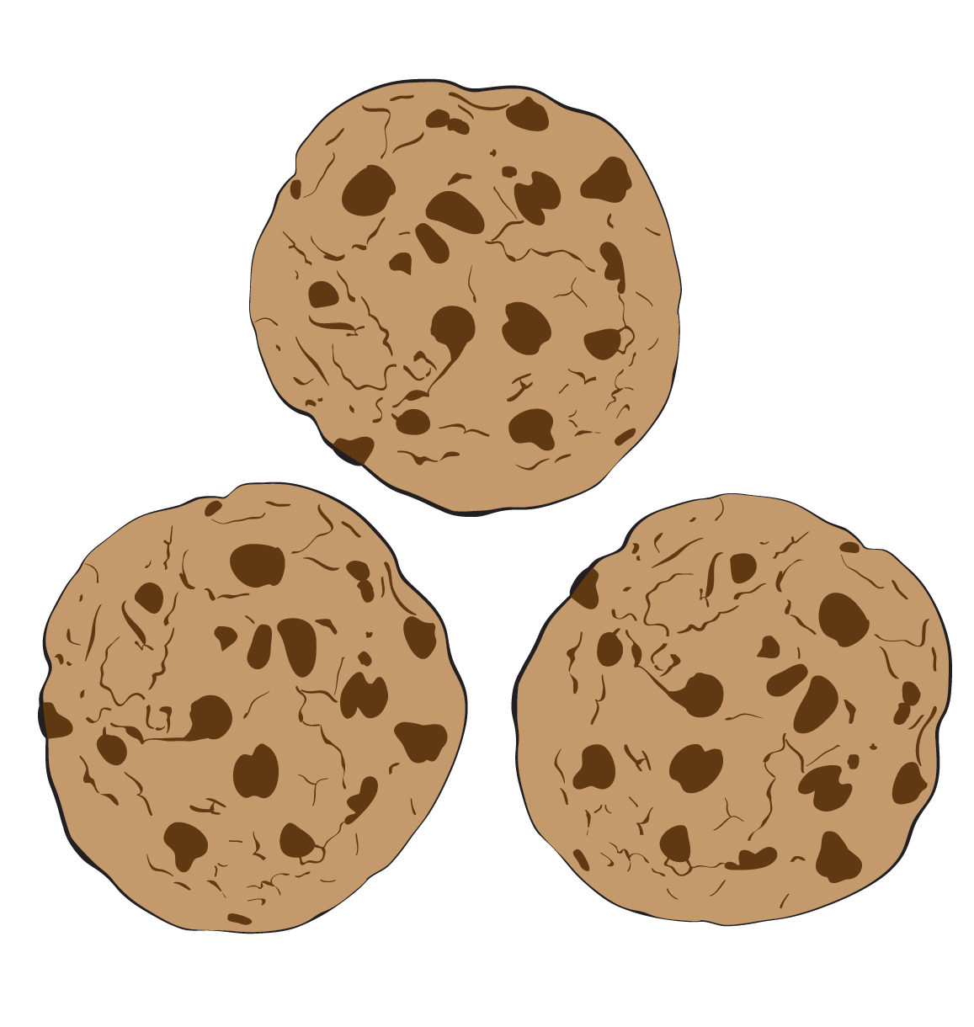Gerry brought 48 cookies to school to celebrate National Cookie Day. He gave a cookie to the 18 students in his third-grade class other than himself. He also gave a cookie to each of the 17 students in the other third-grade class. Then Gerry gave 2 cookies to all 3 of the second-grade teachers and both third-grade teachers.
   1. How many cookies did Gerry give to third-grade students?
   2. How many cookies did Gerry give to the teachers?
   3. How many cookies did Gerry give away altogether?
   4. How many cookies does Gerry have left over?
2. 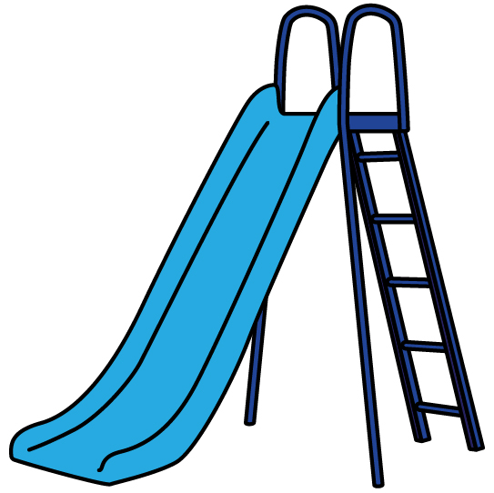Kanzee Elementary School is collecting box tops to raise money to fix the slide on the playground. To start, the principal puts 50 box tops in the bin.
   1. In the first week, three classes all place 30 box tops into the bin. How many box tops are in the bin at the end of the first week?
   2. In the second week, Mr. Prince’s class adds 56 box tops, Mrs. Lowe’s class adds 34 box tops, and Ms. Waller’s class adds 86 box tops. How many box tops are in the bin at the end of the second week?
   3. The school’s goal is to collect 500 box tops. How many more box tops does the school need?

1. 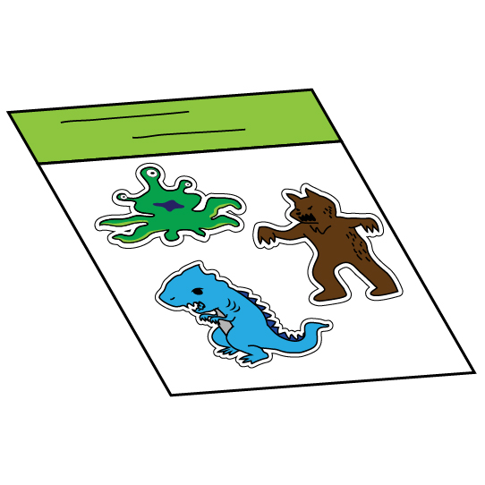Makio has 140 monster stickers in his collection. First, Makio gives half of the monster stickers to his brother. Then he trades 13 monster stickers to his friend Satha for a book.
   1. How many monster stickers does Makio have left?

* 1. Satha has been collecting monster stickers for 3 weeks. Each week, she adds 7 new monster stickers to her collection. How many monster stickers does Satha have after trading with Makio?

* 1. Who has more monster stickers after the trade, Makio or Satha? How many more stickers does that person have compared to the other?

1. Victor is reading a book that has 350 pages. He reads 35 pages on both Sunday and Monday.
   1. Write an equation to represent how many pages Victor has left to read. Use *a* to stand for the amount of pages Victor has left to read.

* 1. Solve for *a*.

* 1. Victor needs to finish the book in 5 more days. How many pages does Victor need to read each day?

1. Johnny wants to buy a book that costs $26. He already has $5 from doing yard work. Johnny plans to save the rest of the money for the book from his weekly allowance of $3.
   1. How many weeks will Johnny need to save money to have enough to buy the book? Explain your answer.
   2. Johnny earns an extra $5 for mowing his neighbor’s lawn. Now how many weeks will Johnny need to save his allowance to buy the book? Explain your answer.
   3. After doing yard work, mowing his neighbor’s yard, and saving his allowance, will Johnny have the exact amount of money needed to buy the book or some extra? If Johnny will have extra money, how much extra will he have?
2. 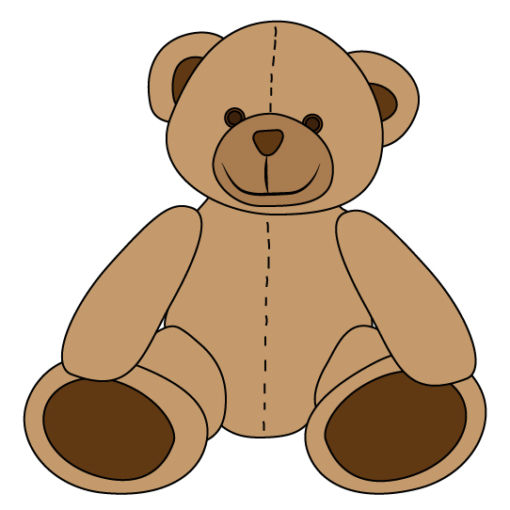Leigha has 14 stuffed animals. Kylee has twice as many stuffed animals as Leigha. How many stuffed animals do Leigha and Kylee have altogether?
   1. What is the first step needed to answer the question?
   2. Find how many stuffed animals Leigha and Kylee have altogether.
3. The following table shows the pounds of pop tabs collected by third, fourth, and fifth-grade classes at South Elementary School, Trails Elementary School, and Frontier School.

|  |  |  |  |
| --- | --- | --- | --- |
|  | **South Elementary School** | **Trails Elementary School** | **Frontier School** |
| **Third Grade** | 10 pounds | 9 pounds | 14 pounds |
| **Fourth Grade** | 8 pounds | 12 pounds | 10 pounds |
| **Fifth Grade** | 12 pounds | 11 pounds | 9 pounds |

* 1. Which school collected the most pop tabs? How much did that school collect?

* 1. Which grade collected the most pop tabs? How much did that grade collect?
  2. South Elementary School finds an extra 2 pounds of pop tabs in a lost collection box. Does this amount change the answer to 7.a? Explain your answer.